Spring 2025
RUSS 323/CWL 323/ENG 323/
TOLSTOY



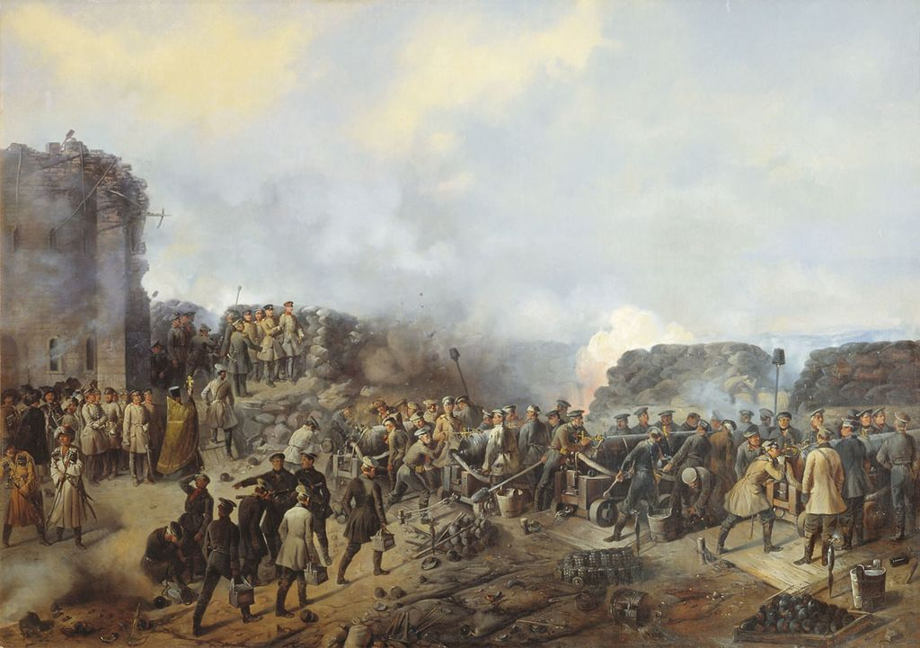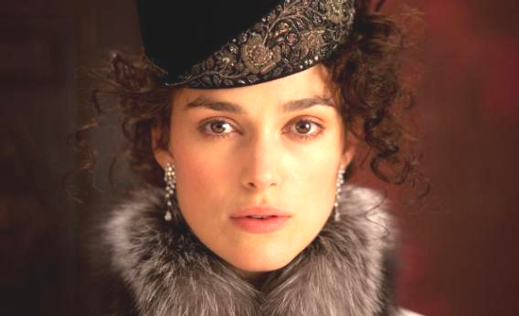

The course will trace Tolstoy’s development as a writer and a deeply conflicted if fascinating thinker. Readings include Childhood, The Sevastopol Stories, The Cossacks, Anna Karenina, The Death of Ivan Il’ich, The Kreutzer Sonata, as well as some of Tolstoy’s philosophical and political works.
No knowledge of Russian is necessary.

Instructor: Prof. Valeria Sobol (vsobol@illinois.edu)
TR 2:00- 3:20 108 Bevier Hall

